**Checking entities of menu icon**

Step 1: Navigate to swag labs site using the URL- <https://www.saucedemo.com/>

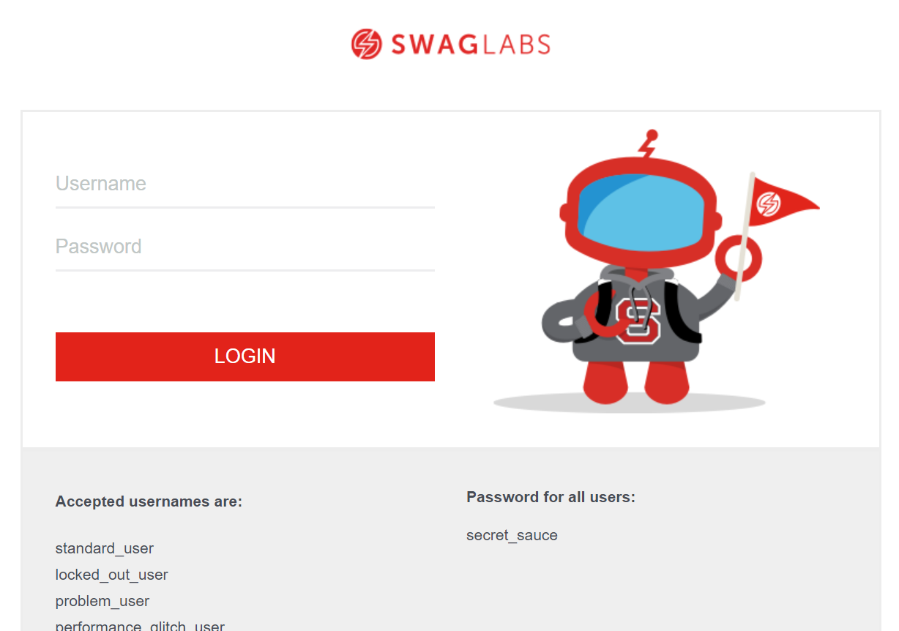

Step 2: Provide valid username and password and click login button, Given: Username= standard_user

Password= secret_sauce

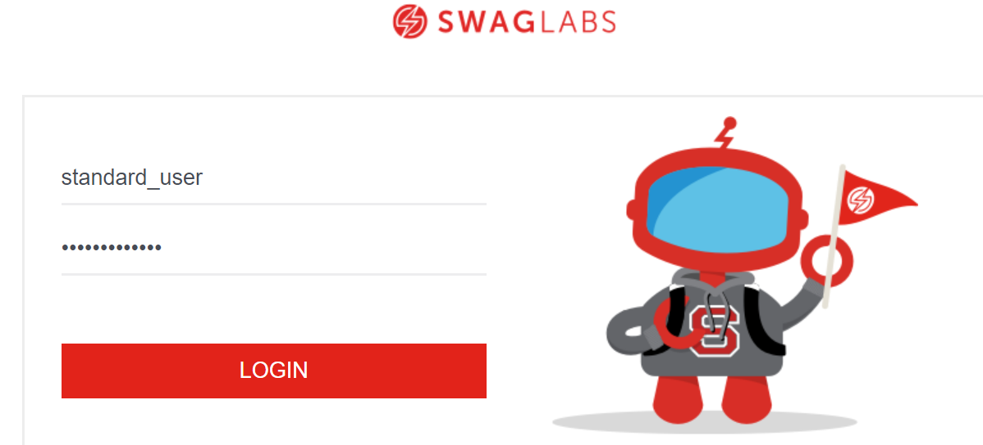

Step 3: Search for menu icon and click on that icon.

Step 4: Checking whether below entities are present on the home page after clicking on that icon. 1. All Items

2. About

3. Logout

